# **Website Setup Instructions:**

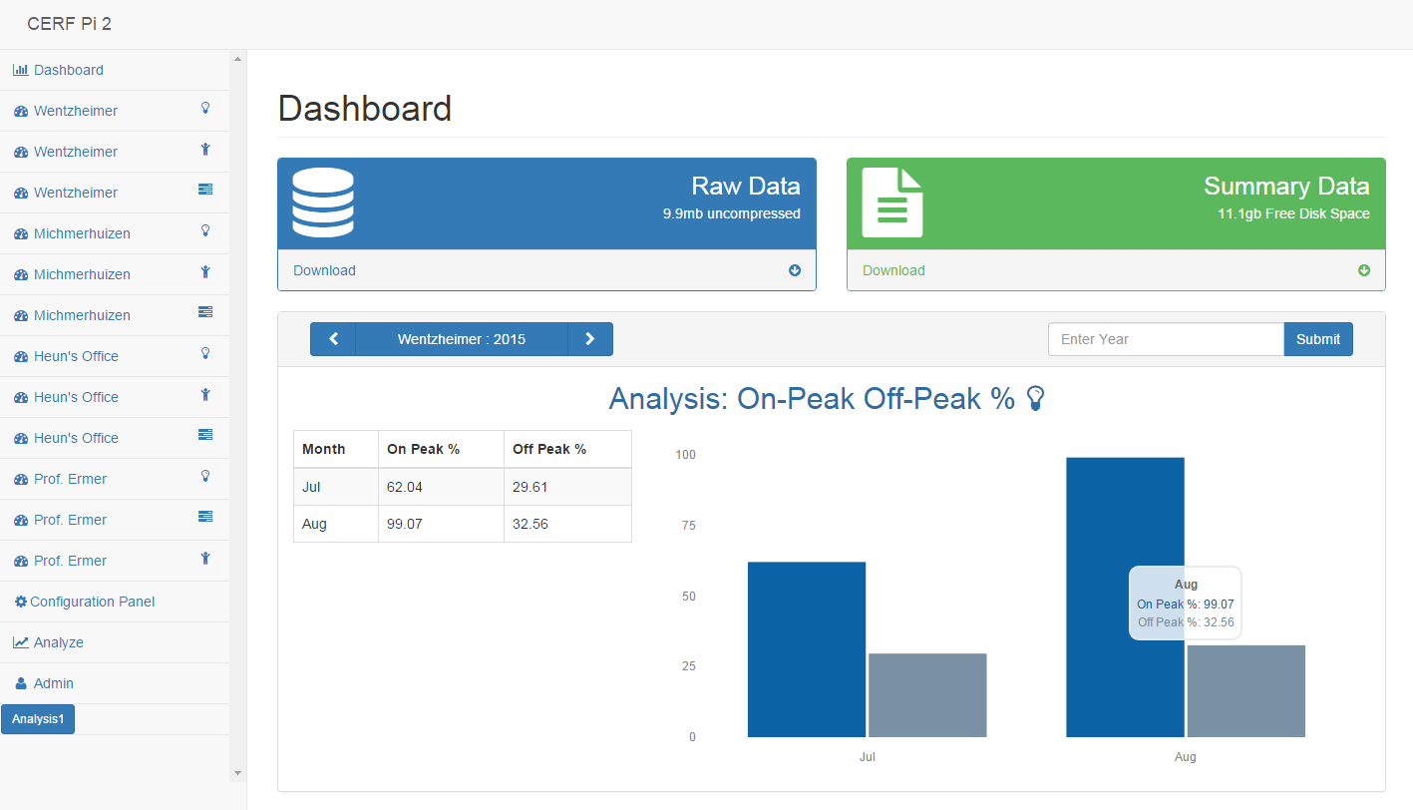

Website Setup Instructions:

Adding Sensors:

Setting up Analysis:

Choosing the Number of Analyses:

Choosing The Analysis Types:

Setting up Bins:

Using Bins with ‘From Sensor’

Using Bins with ‘Custom Time’:

Using the Admin Page:

Using the Analysis Page:

Navigation:

Navigating the Website:

## Adding Sensors:

Start by navigating to the configuration panel:

You will be given a warning that making changes could interfere with data collection. Click OK when you are ready to continue:



To start, indicate how many sensors you have connected to the Raspberry Pi and click submit. The changes will take place immediately:



You will now see a series of sensors pop up underneath the “On-Peak Off-Peak % Analysis Settings”. To open a sensor for editing click the down arrow next to “Sensor X”. Clicking on an arrow when the sensor is already open will cause it to close:



To set up the sensor first type in the name and the type. To obtain the i2c address and pin number look on the side of the Raspberry Pi enclosure and take note of the text by the sensor ports.

* The number following ‘0x’ corresponds to the **i2c Address**
* The number following ‘L’ corresponds to the pin number of the **light sensor**
* The number following ‘T’ corresponds to the pin number of the **temperature sensor**
* The number following ‘O’ corresponds to the pin number of the **occupancy sensor**
* The occupancy sensor does not need an **i2c address**



Click any submit button besides the one for submitting the number of sensors, or the submit button for changing the “On-Peak Off-Peak % Analysis Settings”. This will submit the data for all of the sensors:



This is an unfortunate glitch in the website. Because the Raspberry Pi is writing so much data to the hard drive when recording your submission the website loads before the file is finished writing. As a result, your changes will not be visible. In order to make them visible after hitting submit, click on **Display Updates**. This is important because the website loads the data from the hard drive for the default values in the sensor configuration forms. If after submitting your data, you hit submit again, without first clicking **Display Updates**, all of the sensor configuration data will revert to its previous state:



Example submit and display updates: (Notice the name change from ‘Hello’ to ‘HI’ on the navigation pane of the left hand side of the screen (It is really fast))



## Setting up Analysis:

### Choosing the Number of Analyses:

To set up an Analysis go back to the Configuration Panel, and click the dropdown to edit a sensor. You can chose to have 1, 2, or 3 analysis run on the same sensor:



### Choosing the Analysis Types:

Next choose an analysis type. The different types are as follows:

* **On-Peak Off-Peak %:** This analysis records how often the sensor records values within the specified threshold during on-peak hours, and records a separate value for how often the sensor records values within the specified threshold during off-peak hours. It summarizes the data by month and displays it graphically.
* **Range Analysis:** This analysis records how often the sensors record values within a specified threshold. Unlike peak analysis, it is much more flexible as to what timeframe it performs the analysis in.
* **Min-Max:** This analysis records the min, max, and average values recorded by a sensor during a specified time range.
* **kWhr:** Currently this doesn’t do anything, but it is a placeholder for future sensors types to utilize this analysis.

### Setting up Bins:

Next, for the Range and Min-Max analysis, the bins must be chosen. The bins are the time range that it performs its analysis over. The options for bins are as follows:

* **Year:** performs the analysis over an entire year of data, for every year
* **Month:** performs the analysis over an entire month of data, for every month
* **Day:** performs the analysis over a single day of data, for every day
* **From Sensor:** it performs the analysis over timeframes of data, based on the data from another sensor.
* **Custom Time:** it performs the analysis over a very specific time range.

#### Using Bins with ‘From Sensor’

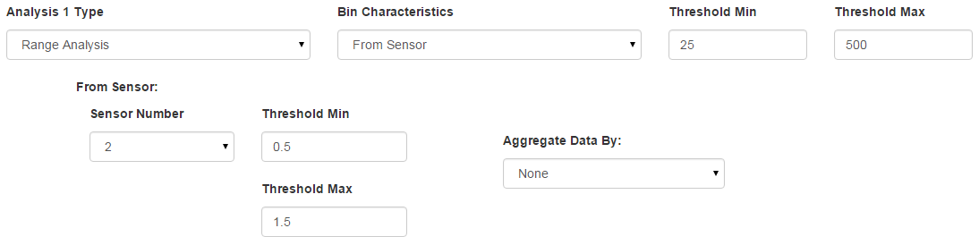

* **Sensor Number:** This sets the number of the sensor you want to use to create the time bins for the current sensor.
* **Threshold Min and Max:** These set the threshold for the sensor you are using to create time bins with. For example, you can see above it shows using sensor 2 (Occupancy - whose values range from 0 to 1). Therefore as long as the room is occupied (value of 1) the values will be between 0.5 and 1, and it will create an “In Range” Time bin. If the room is unoccupied (value of 0) it will create an “Out of Range” time bin for as long as the room is unoccupied.
* **Aggregate Data By:** Using the previous example, because a room may become occupied and then unoccupied twenty times in a day, the analysis becomes convoluted and hard to understand. (See picture below) Therefore, you can chose to aggregate the data by Month or Year (See the second picture below).

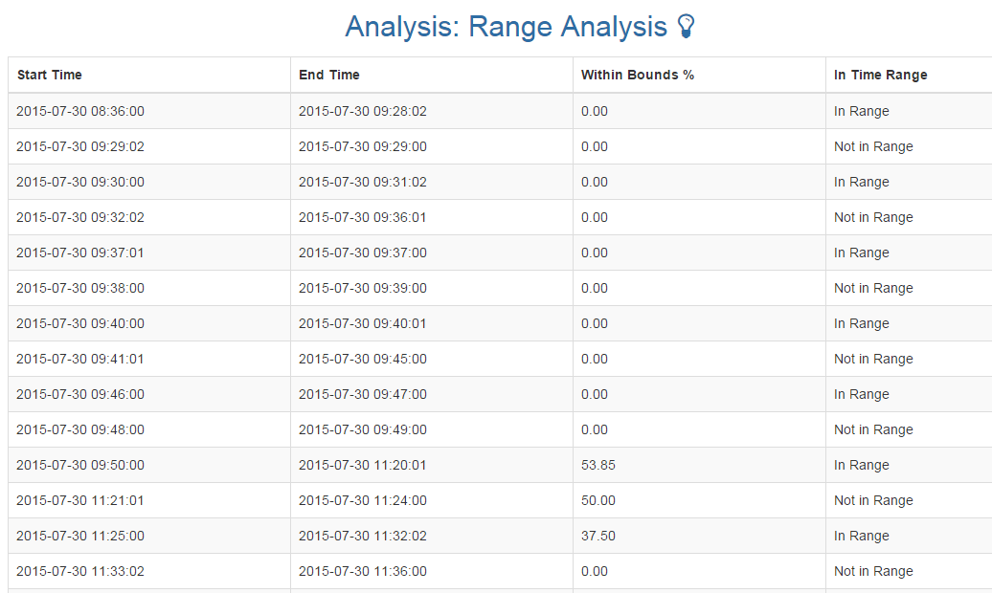

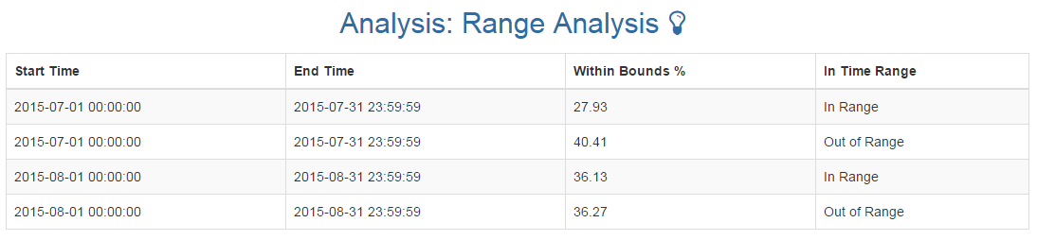

#### Using Bins with ‘Custom Time’:

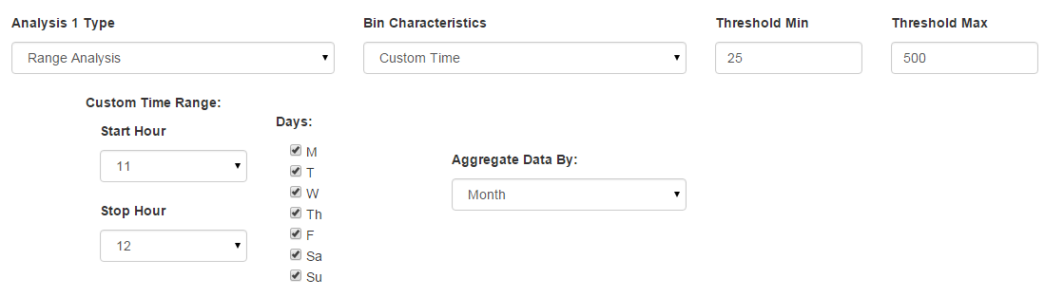

**Start and Stop Hour:** The analysis will count hours between these two times as “In Range” and all other times as “Out of Range”. If the start time was 11 and the stop time was 17 then the analysis would count 11:00:00AM to 4:59:59PM as “In Range” and all other times as “Out of Range”.

**Days:** The analysis will count all checked days as “In Range” and all other days as “Out of Range”.

**Aggregate Data By:** The data is already partially aggregated by day, which is why it is not an Aggregation technique. However, if seeing a bin for every day is too much information you can chose to summarize it by month or year.

Below is a picture of the Custom time analysis with start hour 11 and stop hour 17. With days Monday through Friday. You can see that it skips August 1 and 2 because these are Saturday and Sunday, and you can see how it puts the times between 11 and 17 into the “In Range” Bin and the rest of the times into the “Out of Range” bin:

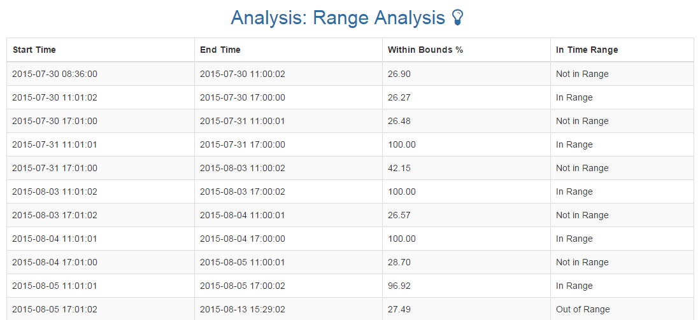

## Using the Admin Page:

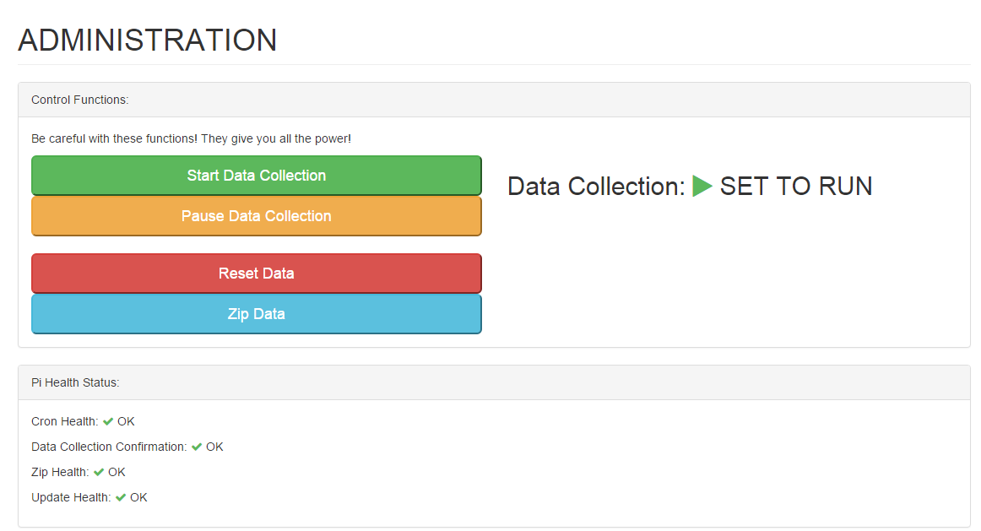

The four commands allow you to perform some different commands on the Raspberry Pi:

* **Start Data Collection:** Sets a parameter on the pi so that at the top of the minute, every minute, the data will be collected. When pressed it will spin until the data collection is set to run. At which point the message on the side will change.
* **Pause Data Collection:** Sets a parameter on the pi so that at the top of the minute, every minute, the data will not be collected, even when the scheduled task runs. When pressed it will spin until the data collection is set to paused. At which point the message on the side will change.



* **Reset Data:** Removes all the data on the pi (Careful with this one). It does give you a chance to confirm in case you accidentally pressed it:



* **Zip Data:** Zips all of the data on the pi so that it can be downloaded from the Dashboard page. It will say “Not Running” until it is finished. This may seem like a mistake, because it is running. This is because the parameter Zip Health is set to OK whenever a succesful zip is completed, and it is set to NOT RUNNING when the zip starts. This way if the automatically scheduled zip that happens every midnight fails, you will know as the Zip Health will say NOT RUNNING. Try to press the zip data button again to get the most recent information. If this doesn’t work refer to the next paragraph See below:



The bottom of the page contains a health monitor. This will let you know if the automatically scheduled events are running as they should. If for any reason they stop a red warning triangle will appear. To look into the reason for these errors there is an error log. It is found by navigating to the folder /dev.



You can see one log in the folder already. The list of error log files is:

* GetDataCron.log
* AnalysisCron.log
* UpdatePiCron.log
* ZipCron.log

This is a sample output of one of the log files:

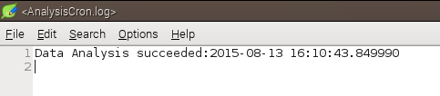

As a further note, when setting the pi to start data collection, or pause data collection, you are only setting a parameter (because the command to fetch the data from the sensors needs extra privileges that cause security problems if the website is allowed to run them). Therefore the data collection is handled by an automatic scheduler on the Raspberry Pi. The indicator at the top “set to run” or “set to pause” only tells you if you have set the parameter correctly to tell the automatic scheduler to either collect the data, or ignore the data collection. The health indicator at the bottom tells you if the automatically scheduled task has run correctly. At the top of the minute the data collection service will run and the status of the data collection will be updated at that time. See below for examples: 



## Using the Analysis Page:

Navigate to the Analysis page.



It is pretty self explanatory. Just click the button! The website runs the analysis every night at midnight, but if you need an update analysis or if you made changes then feel free to use this tool. (Be warned it does take some time)



Note: The animation has been sped up to show the progression.



## Navigation:

### Navigating the Website:

Navigate through the sensors by clicking the navigation bars on the left side of the screen:



Navigate through different days of data using the arrow keys at the top of the graph:



Navigate through different years of analysis by clicking the arrows at the top of the analysis (Nothing shows up because we haven’t taken multiple years of data yet):



You can view the parameters for the different analyses at the bottom of the navigation bar. If there is more than one analysis you can view the different analysis by clicking the different buttons:

